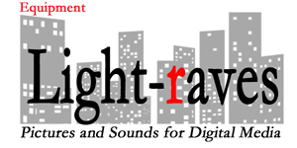

Sample Partial Travel Equipment List:

-Cameras of choice: Sony FS-7, FS-5, Canon C500 or C300
-Second Camera: mirrorless Sony
-GoPro for vehicle mounts
-2 x Astra 12*12s
-Lite panels camera light
-Sachtler tripod
-2 Chimera soft boxes with 1000, 750 and 500 watt lamps
-Dedo background light with projector attachment for patterns
-Assorted small LEDs with home-plates for backlight, balance for Ultimatte screens
-42" Flex silk and Flex-fill white, black, silver
-Extension cords
-Sound devices: 633 mixer with umbilical cable and quick disconnect
-2 Lectrosonic wirelesses with Trams or Sankens
-Sennheiser boom mike with Rycote softie, power supply, boom pole and cables
-2 sets Sony 3506 headsets
-Make-up kit
-Travel stools for quick interview
-Adapter kit for foreign travel
-Small grip kit and tool kit.

©2021 www.light-raves.com / (781)883-5300 / bruce@light-raves.com

